**Tips to Sleep Better at Home**



**Regular Sleep Patterns:** Maintain a consistent sleep schedule 7 days a week. Go to bed and wake up at the same time every day. This sets your body’s internal clock for optimal sleep.

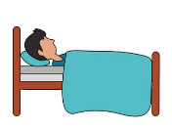

**Only Use the Bedroom to Sleep:** Don’t watch TV or work in the bedroom, use it only to relax and sleep.

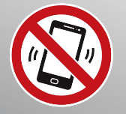

**Avoid Screen Time at Night**: Stop using electronic devices 1 hour before bedtime. White and blue light from electronic devices interferes with the release of melatonin which provides the signal to sleep.



**Relax:** Avoid stressful and activating activities and try relaxation techniques like, meditation, stretching, listening to music, reading, diming the lights or drinking herbal tea.



**Set-up a Bedtime Routine:** Set-up an evening wind-down routine bydoing the same activities right before bed (showering, brushing your teeth, praying, or put on pajamas), so your body knows its bedtime and can get sleepy.



**Keep Cool and Comfortable:** Lower the thermostat between 68-72 degrees, keep the bedroom dark, quiet, and comfortable.



**Avoid Caffeine, Nicotine, and Alcohol:** Avoid caffeine (coffee, energy drinks or teas), nicotine (cigarettes, vaporizers, chewing tobacco) and alcohol (beer, wine, liquor) before bed. These disrupt your sleep cycle and may wake you up with withdrawal symptoms.



**Exercise:** Regular exercise can help you sleep better. Schedule high-intensity workouts earlier in the day and avoid exercising 4 hours before bed time.

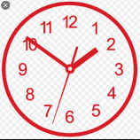

**Don’t Check the Clock:** If you’re not tired, and can’t sleep, don’t check the time. This means you’ll be tossing and turning and you’ll get frustrated. Instead do something soothing and try again later.

**Tips to Sleep Better Operationally**

**Bank Sleep:** Get as much sleep as possible the week before the operation so that you start the mission with a full bank of sleep (e.g., 10 hours/night).



**Take Naps**: When sleep is limited use every opportunity to nap (preferably greater than 20 minutes). Nap as much as possible to get 7-9 hours of sleep every 24 hours.

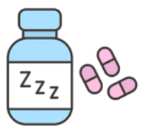

**Don’t use Sleeping Pills:** Sedatives like sleeping pills are not recommended for military personnel. In an operational situation, the risk of impairing critical performance is high.It is best to consult with your doctor about using sleeping pills. Make sure to never mix them with alcohol.



**Unbroken Sleep:** Try to sleep 4-5 hours in a single, unbroken period each 24 hours. This amount of sleep should be adequate to maintain maximum performance for a month or longer.



**Use Sleeping Aids:** If possible, wear headphones, ear plugs, or eye masks to darken the room and eliminate noise around you.



**Train yourself to be an Effective Sleeper:** Learn techniques to help induce sleep under unusual and stressful conditions.

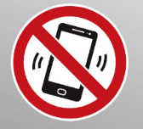

**Avoid Screen Time at Night**: Stop using electronic devices 1 hour before bedtime. White and blue light from electronic devices interferes with the release of melatonin which provides the signal to sleep.



**Relax:** Avoid stressful and activating activities and try relaxation techniques like, meditation, stretching, listening to music, or reading.



**Restrict the use of Caffeine:** Energy pills andcaffeinated beverages like coffee and energy drinks should be limited. Try to avoid consumption 6 hours before bed.